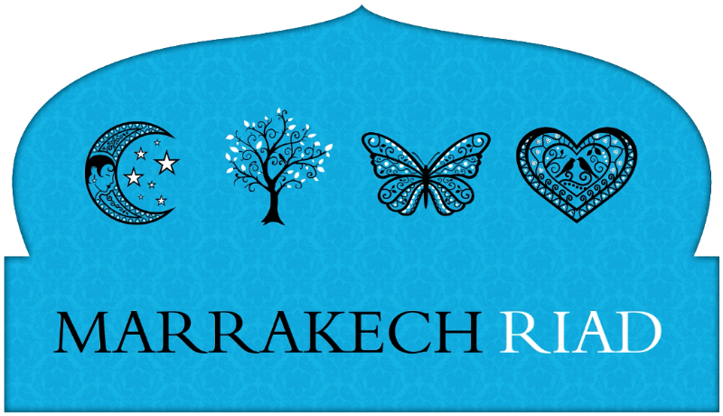

New, Improved, Indispens-App-le Guide to Marrakech Now Available

A new, enhanced version of the indispensable app for visitors to Marrakech by local experts, Marrakech Riad is now available and free to download from iTunes.

Described by one visitor as a “godsend”, the app is currently ranked number 2 for Marrakech in iTunes and has had 10,000 downloads since its initial launch last December. Original features include a comprehensive GPS responsive map of the old town medina to save visitors getting lost in the maze of bustling streets, background profiles on popular tourist attractions and up to the minute guides to restaurants and bars, written by Marrakech Riad owner and local expert, Mike Wood.

The new version now also includes:

- Added walks through 4 historic districts of Marrakech
- A bigger, doubled-in-size map featuring the new town as well as the medina
- Information on 50% more tourist attractions
- Added discounts at more than a dozen top restaurants
- Added information on day excursions from Marrakech

Version 2 of the app is available to download now from iTunes: https://itunes.apple.com/gb/app/marrakech-riad-travel-guide/id489129273?mt=8.

About Marrakech Riad – English owned and managed, Marrakech Riad consists of four boutique hotels in the old town Medina of Marrakech. Riad Papillon, Riad Cinnamon, Dar Habiba and the latest addition to the portfolio, Riad Star, have been painstakingly restored working with traditional materials and craftsmen while incorporating modern conveniences. Each has its own distinctive personality and all offer outstanding service. From romantic escapes to relaxing family breaks and group get-togethers, the four stylish houses offer the perfect retreat in Morocco’s captivating imperial city.

-ENDS-

For further information on Marrakech Riad, please visit www.marrakech-riad.co.uk. Media enquiries should be directed to Samantha Kirton on 0778 616 6556 or e-mail: samantha@keenecomms.com

